**SYSTEM DESIGN**

**6.1 SYSTEM ARCHITECTURE**

Enroll Student

Upload Certificate Credential

Update Certificate

View Students

Logout

Send Access Request

Access Certificate

Logout

View Your Details

Access Certificates

View Access Request  
Logout

**6.2 UML DIAGRAMS**

**6.2.1 USE CASE DIAGRAM**



**\**

**6.2.2 CLASS DIAGRAM**



**6.2.3 SEQUENCE DIAGRAM**



**6.2.4 COLLABRATION DIAGRAM**



**6.2.5 ACTIVITY DIAGRAM**

Register

Login

No

Start

Yes

Login Again

University

Register

Login

Enroll Students

Upload Certificates Credential

Company

Register

Login

Send Access Request

Access Certificates

Logout

Upload Certificate

View Students

Logout

End

Student

Login

View Your Details

Access Certificates

**6.2.6 COMPONENT DIAGRAM**



**6.2.7 DEPLOYMENT DIAGRAM**



**6.2.8 ER DIAGRAM**

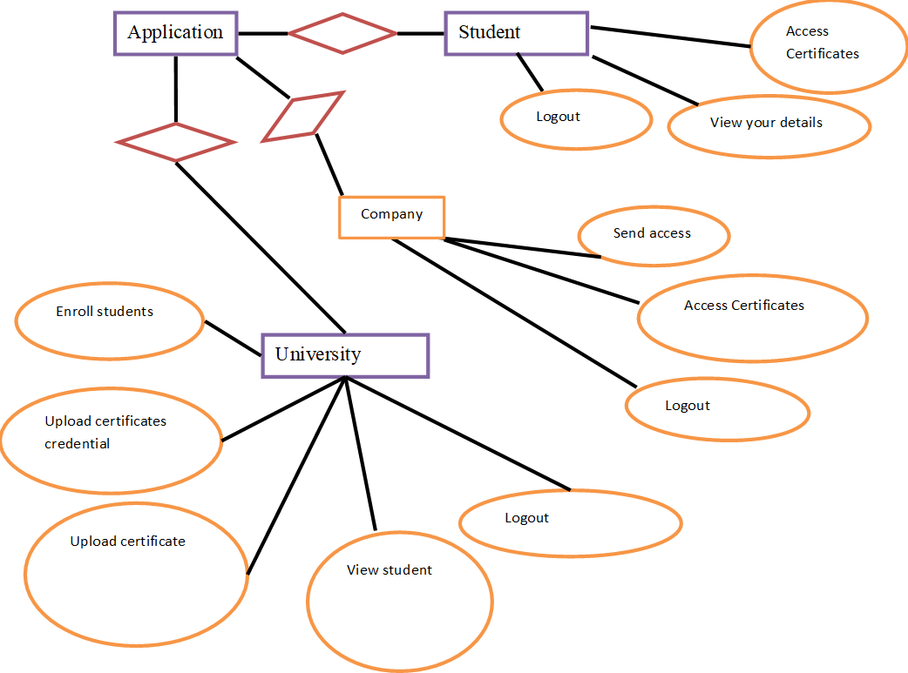

**6.2.9 DATA DICTIONARY**

**Database:** streamlining credential verification for hiring processes with blockchain technology

methods

Table name: auth_group

|  |  |  |  |
| --- | --- | --- | --- |
| Column | Data Type | Constraints | Description |
| id | Int(11) | Primary key | Unique Identifier |
| name | Varchar(1000) | Not null | name |

|  |  |  |  |
| --- | --- | --- | --- |
| Column | Data Type | Constraints | Description |
| id | Int(11) | Primary key | Unique Identifier |
| Group id | Int(11) | Primary Key | Unique Identifier |
| Permission_id | Int(11) | Primary Key | Unique Identifier |

Table Name: Auth_group_Permission

Table Name: auth_permission

|  |  |  |  |
| --- | --- | --- | --- |
| Column | Data Type | Constraints | Description |
| id | Int(11) | Primary key | Unique Identifier |
| Name | Int(255) | Not Null | name |
| Content_type_id | Int(11) | Primary Key | Unique Identifier |
| Code name | Int(100) | Not Null | name |

Table Name: auth_User

|  |  |  |  |
| --- | --- | --- | --- |
| Column | Data Type | Constraints | Description |
| id | Int(11) | Primary key | Unique Identifier |
| Password | varchar(128) | Not Null | password |
| Last_Login | Datetime(6) | Not Null | Last login |
| Is_superuser | tinyint(1) | Not Null | Name |
| username | Varchar(150) | Not Null | Username |
| lastname | Varchar(30) | Not Null | Lastname |
| email | Varchar(150) | Not Null | Email id |
| Is_staff | Tinyint(1) | Not Null | Staff |
| Is_active | Tinyint(1) | Not Null | Active |
| Date_joined | Datetime(6) | Not Null | Date and time |

Table Name: auth_user_groups

|  |  |  |  |
| --- | --- | --- | --- |
| Column | Data Type | Constraints | Description |
| id | Int(11) | Primary key | Unique Identifier |
| User_id | Int(11) | Primary Key | Unique Identifier |
| Group_id | Int(11) | Primary Key | Unique Identifier |